
The 4th Annual
Otis Invitational

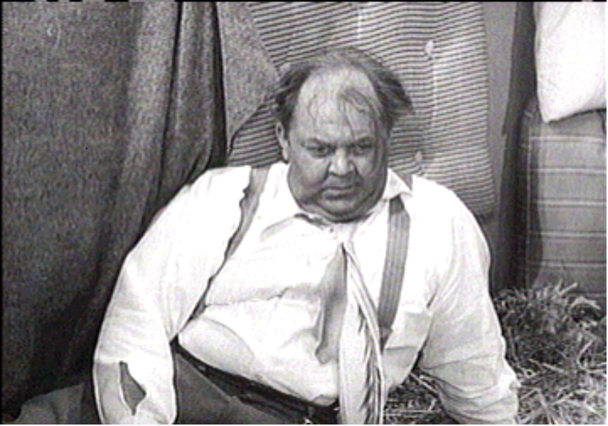

June 22, 23, 24 - 2001

Hosted By
Thornapple Creek Golf Club
Heritage Glen Golf Club

www.svs.com/zim/otis
 $5.75 
4th Annual Otis Invitational

Welcome Otis Participants!

This program will become your Otis bible, containing and pertaining to everything you could want to know about the tournament.

The most important rule is to have a great time.

And in addition to the rules, this program contains prize money info, format, tee times, logistics, and of course, the now infamous Player Bios.

The logistics section includes directions, multiple maps, and for those of you enjoy taking the back-roads, phone numbers for when you get lost.

Our final count for 2001 is again at 40 players.

If you cannot play, let us know immediately, so we can fill your spot. Uneven scramble teams are no fun for anybody. Also, we have already committed to bring 40 people, and deposits have been paid. If we can’t replace you, you may not get a refund.

Make sure you reserve your room at the Red Roof Inn. Call them at 616-375-7400. Rooms are $65.99 per night double occupancy. Each room will have 2 double beds. To Reserve your room, call by June 7, 2001 for the Otis Golf Outing – Jason Zimberoff, confirmation #0250170376.

Tee times begin at 8:00 AM on Friday, Saturday and Sunday. Please make sure you get to the course ahead of time. Please show up by 8:00 AM even if you are not teeing off first. There is a snack shop and driving range at Thornapple for you to use to wake up and warm up.

Soft spikes are required, so bring a replacement set of spikes if you still use the metal ones.

We will play the Blue and White tees at both courses. We will play the white tees for the individual rounds, and the blue tees for the scrambles. This is different from previous years.

We will have a group dinner on Saturday at Gallagher’s (formerly Chianti’s) on Stadium Drive, a few blocks east of the Red Roof Inn. We hope everyone will participate. The dinner price is included in your entrance fee, and includes appetizers, salad, bread, and non-alcoholic beverages. Alcohol is extra, and will be added to everyone’s separate checks. Since we have a large group, there will be a menu of 3 choices, included near the end of this program.

We will also be meeting in the bar at Chianti’s on Thursday (after 9:00 p.m.) if you are interested in meeting up with many of the participants before the tournament.

The Prizes will be distributed as follows:

Closest To The Pin (4 holes per round, all 5 rounds) $30
Long Drive (1 hole per round, all 5 rounds) $30

Long Putt (1 hole per round, all 5 rounds) $30

Low Net 1st place (one person, each stroke play round) $45
Low Net 2nd place (one person, each stroke play round) $35
Low Net 3rd place (one person, each stroke play round) $25
Low Net 4th place (one person, each stroke play round) $15
Low Net 5th place (one person, each stroke play round) $10
Low Net 6th place (one person, each stroke play round) $5

Scramble Team Winners (each person, each scramble round) $50
Scramble Team 2nd place (each person, each scramble round) $35
Scramble Team 3rd place (each person, each scramble round) $25
Scramble Team 4th place (each person, each scramble round) $10
Scramble Team 5th place (each person, each scramble round) $5

Best Ball Team Winners (each person, each scramble round) $20
Best Ball Team 2nd place (each person, each scramble round) $15
Best Ball Team 3rd place (each person, each scramble round) $10
Best Ball Team 4th place (each person, each scramble round) $5

Highest Total Net Score for two individual play rounds $5

The golf fees for all 5 rounds will be $190 per person (includes green fees and riding cart)
Betting / prize / Saturday dinner money is $110 for the entire weekend.

Total cost per person: $300 (not including the hotel room.)

Birdie pool is optional. If you get in, you will pay $1 for every birdie made by others, and receive $1 from everyone else if you make a birdie. If someone scores an eagle, it will be counted as 2 birdies. A double eagle will count as 3 birdies. (Ya never know....)

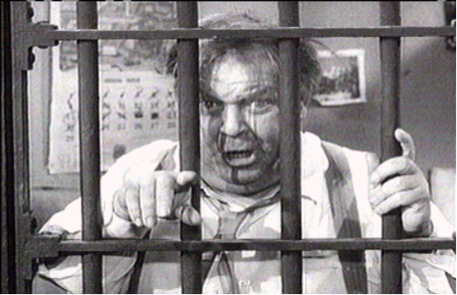

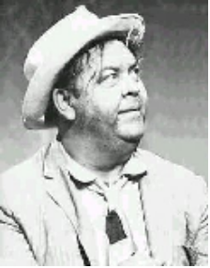

2001 Otis Invitational
Official Otis Format

Friday AM - Stroke play with your foursome at Thornapple. Prizes are awarded for the 4 closest to the pin markers, long drive in the fairway on #9 (a very narrow par 5), longest putt made on #14, and to the top 6 finishers.

Friday PM – 4 man scramble play at Thornapple. Teams are determined by a high/low pairing based on your pre-tournament approved score. For example, each team would consist of players ranked in the A, B, C, and D tiers (to be determined ahead of time.) Prizes are awarded for the 4 closest to the pin markers, long drive in the fairway on #18, longest putt made on #18, and to the top 5 teams.

Saturday AM - Stroke play and best ball with your foursome at Heritage Glen. Prizes are awarded for the 4 closest to the pin markers, long drive in the fairway on #8, longest putt made on #7, and to the top 6 stroke play finishers. Also, new this year, prizes for the top 4 best ball teams (your team’s 2 best out of 4 handicapped scores on each hole.)

Saturday PM - Handicapped 4 man scramble play at Heritage Glen. Teams are determined by a blind draw with two players from the “A” pool (players 1-20) and two from the “B” pool (players 21-40). Handicaps are computed based your pre approved average score. The scale is as follows: an Average score less than 80 is a 0, 80-84 is a 1, 85-89 is a 2, 90-94 is a 3, 95-99 is a 4, 100-104 is a 5, and greater than 105 is a 6. If your team has players who average 82, 84, 96, and 112, you would receive a handicap of 12. Prizes are awarded for the 4 closest to the pin markers, long drive in the fairway on #18, longest putt made on #18, and to the top 5 teams.

Sunday AM - 4 man scramble play at Thornapple. For this round, we will re-rank all of the players based on your average from the Friday morning round. Teams are determined by a high/low pairing based on your average scores. For example, one team would consist of players re-ranked 1-40-20-21, the next team would be 2-39-19-22, etc. Prizes are awarded for the 4 closest to the pin markers, long drive on #18, longest putt made on #18, and to the top 5 teams.

Official Otis Logistics

Tournament Date: Weekend of Friday, June 22, 2001

Tournament Location: Thornapple Creek Country Club
Kalamazoo, Michigan (616) 344-0040

Heritage Glen Golf Club
Paw Paw, Michigan (616) 657-2552

Motel Accommodations: Red Roof Inn
(US 131 at Stadium Drive, Exit 36B, 616-375-7400)
Rooms are $65.99 per night double occupancy.
Each room will have 2 double beds.
To Reserve your room, call Red Roof Inns at 616-375-7400 by
June 7, 2001 reserved by Jason Zimberoff, confirmation #0250170376

Saturday Night Dinner: We will have the entire group eat together at Gallagher’s Restaurant (formerly Chianti’s) in Kalamazoo on Saturday night. Your dinner is included in the entry fee. Alcohol is extra. Details to be announced. Many of us will meet there Thursday night if you would like to come. For other meals, you are on your own. There are many good spots to eat around the hotel.

Tournament Format: 36 Holes on Friday and Saturday, 18 Holes on Sunday

Cost Breakdown: Greens Fees are $190 for the entire weekend. This includes 90 holes of golf,
($300 Total per person) and a riding cart. Betting, Prize and Dinner money is $110 for the entire weekend. (for closest to the pin, low net, long drive, long putt, scramble winners, the dinner, and other goodies.)
Birdie pool is optional. If you get in, you will pay $1 for every birdie made by others, and receive $1 from everyone else for each birdie you make. Please send all checks to Rob Westover, 1011 Bear Paw Ct. Carol Stream, IL 60188

Tee Times: Begin at 8:00am and 2:30pm.

Player Handicaps: Your handicap will be determined by a mutually agreed upon average score.
If you have not played with us before, you will need to agree on a score with
someone who has. We will adjust your score up or down if we determine that
you normally play a very easy or difficult course. We ask you to be honest. The
competition will not be very much fun if there are a lot of “sandbaggers”.

Other information call Jason Zimberoff at 630-876-0023 Note New Number!
Bump Waghorne at 630-736-8170
Mike Redenbaugh at 630-462-6859
Rob Westover at 630-876-0023 Note New Number!
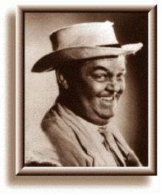
2001 Otis Invitational

Official Otis Rules

Unless otherwise stated by the rules committee (Jason, Bump and Mike), USGA rules apply. Here are some clarifications and local rules that should help eliminate confusion.

SHOW UP!
We go through a lot of planning to set up the Otis each year, so if you cannot make it, please do everything possible to tell us early and we will try to find a replacement. Uneven scramble teams are not fun for anybody. If you play, you will be among the first to get invited back every year!

PLAY WHEN YOU ARE SCHEDULED! (This is a new point of emphasis this year!)

It is difficult to set up the tee times so that people do not play with the same foursome every day, and still
keep teams fairly even. If you cannot play in the first or last tee time Sunday morning, you are not Otis material and you should stay home! Even though your odds are good that you will play when you want, be prepared to stick it out till the last minute. Do not assume you can get home early on Sunday. Make your travel plans accordingly. You have been warned.

NO COMPLAINING about the conditions or rules!

NO GIMMIES!

KEEP PACE:
Please take no more than 10 strokes per hole. If you hit the ball 10 times and are still not in the hole,
give it up and move on!

Please keep up with the group ahead of you. We need to get a lot of people through the course in time
to tee off again in the afternoon, and we do not want dinner to be later than it has to be.

RAIN:
You are expected to play through all weather. We follow a modified Otis rule.(The original Otis rule is, if the bar is open, you must drink!), thus the modified rule is, if the course is open you must play. With this in mind, be prepared with an umbrella, rain suit, multiple towels, and spare gloves. As Bill Murray would say, “I don’t think the heavy stuff will come down for a while now.” Remember, we are coming a long way to play, so be prepared! Besides, everyone will face the same conditions.

SHIRTS & SHOES:
Soft Spike shoes are required. Most of us have converted by now, but it is still worth mentioning. Please wear shirts with a collar.

TEE TIMES
Arrive at least 20 minutes before your morning tee time.

MOVING THE BALL:
Rough - Moving the ball is absolutely not allowed
Fairway - You are allowed to move the ball no more than six inches

OUT OF BOUNDS:
Thornapple - All holes - you are allowed to drop the ball where it went OB with a ONE stroke penalty.
Heritage - All holes - you are allowed to drop the ball where it went OB with a ONE stroke penalty.

If the ball is OB but playable, you still must drop it back in play and take the one stroke penalty!

LOST BALLS:
You may drop a ball in the area where you think the ball disappeared (you must get agreement from
your partners on the spot), and then take a ONE stroke penalty.

WATER HAZARDS:
Standard - Drop where the ball crossed the margin of the hazard, one stroke penalty (i.e., on a par 3
if you hit your tee shot in the water, after your drop, you will be hitting your 3rd shot.)
Exceptions - #4 at Thornapple: Off the tee, drop on the other side of the marsh by the cart path
#5 at Thornapple: Off the tee, drop on the other side of the lake directly in front of the tee
#17 at Thornapple: Off the tee, drop in the official drop area (if marked), otherwise,
drop just short and to the right of the green.
#11 at Heritage Off the tee, drop on the other side of the marsh.
#16 at Heritage Off the tee, drop on the other side of the lake.

TEE MARKERS: (New policy!)
Blue tees on all 18 holes for scrambles, White tees on all 18 holes for individual rounds.

SCORECARDS:
Must be signed by each member of the group and given to Barney Fife (who will be named before each round).

SCRAMBLES:
Drives: Minimum of 2 drives must be used from each player
Position - You must hit your shot within 1 club length of where the ball was marked. You can
not change the playing surface (i.e., if you are in the rough or sand you must play the ball from
the rough or sand). Also, you may not move the ball closer to the hole.
Putting: Once the ball is in the hole, that is your score (i.e., DON”T tap the ball in if someone else still
has a chance to make the putt!!)
Finish: Weather permitting, wait at least 30 feet behind the green for the following groups.
Friday AM Tee Times
Tee Time Name Score
 | Mike Redenbaugh | 83
8:00 AM | Ken Redenbaugh | 105
 | Jason Zimberoff | 93
 | Bryan Rehfeldt | 100
 | Adam Kommers | 90
 | Bob Kommers | 105
 | Phil Joschko | 100
 | Mark Mayock | 90
 | Lance Murphy | 104
 | Bump Waghorne | 96
 | Jack Westover | 93
 | Joe Booth | 105
 | Steve Rehfeldt | 103
 | Jim Bartelt | 93
 | Jim Spade | 120
 | Al Holloway | 120
 | Chris Schoenfeld | 83
 | Scott Kossman | 108
 | Dave Compton | 98
 | Darryl Krumwiede | 94
 | John Caldwell | 86
 | Greg Wilson | 88
 | Steve Ryan | 100
 | Larry Ryan | 96
 | Jeff Cartwright | 108
 | Rob Westover | 115
 | Larry Grant | 108
 | Bill Wahl | 94
 | Al Gasteier | 103
 | John Hayes | 103
 | Bill Boston | 93
 | Mike Reda | 95
 | Bill Krueger | 83
 | Jeff Thompson | 101
 | Jordan Zimberoff | 98
 | Kai Bobkowski | 88
Friday Afternoon Scramble
Name AM Group Otis Score
 | Mark Mayock | 2 | 90
 | Darryl Krumwiede | 5 | 94
 | Bryan Rehfeldt | 1 | 100
 | Joe Booth | 3 | 105
 | Jack Westover | 3 | 93
 | Jason Zimberoff | 1 | 93
 | Phil Joschko | 2 | 100
 | Ken Redenbaugh | 1 | 105
 | Adam Kommers | 2 | 90
 | Jim Bartelt | 4 | 93
 | Dave Compton | 5 | 98
 | Bob Kommers | 2 | 105
 | Mike Redenbaugh | 1 | 83
 | Larry Ryan | 6 | 96
 | Steve Rehfeldt | 4 | 103
 | Scott Kossman | 5 | 108
 | Greg Wilson | 6 | 88
 | Bill Wahl | 7 | 94
 | Lance Murphy | 3 | 104
 | Jim Spade | 4 | 120
 | Chris Schoenfeld | 5 | 83
 | Jordan Zimberoff | 9 | 98
 | Al Gasteier | 8 | 103
 | Al Holloway | 4 | 120
 | Bill Krueger | 9 | 83
 | Bump Waghorne | 3 | 96
 | John Hayes | 8 | 103
 | Larry Grant | 7 | 108
 | John Caldwell | 6 | 86
 | Bill Boston | 8 | 93
 | Jeff Thompson | 9 | 101
 | Rob Westover | 7 | 115
 | Kai Bobkowski | 9 | 88
 | Mike Reda | 8 | 95
 | Steve Ryan | 6 | 100
 | Jeff Cartwright | 7 | 108
Saturday AM Tee Times
Name Score Otis Hdcp PM Group
Al Gasteier | 103 | 20 | 4
Jordan Zimberoff | 98 | 15 | 2
Jeff Thompson | 101 | 18 | 1
Jim Bartelt | 93 | 10 | 3
Greg Wilson | 88 | 5 | 1
Larry Grant | 108 | 25 | 3
Al Holloway | 120 | 37 | 4
Bill Krueger | 83 | 0 | 3
Pat Di Domenico | 105 | 22 | 1
Jeff Cartwright | 108 | 25 | 2
Lance Murphy | 104 | 21 | 3
Bill Wahl | 94 | 11 | 4
John Caldwell | 86 | 3 | 2
Ken Redenbaugh | 105 | 22 | 6
Kai Bobkowski | 88 | 5 | 5
Jim Kveton | 93 | 10 | 1
Brandan Mueller | 100 | 17 | 5
Scott Kossman | 108 | 25 | 5
Bill Boston | 93 | 10 | 2
Darryl Krumwiede | 94 | 11 | 6
Mike Redenbaugh | 83 | 0 | 7
Mark Mayock | 90 | 7 | 9
Tim Monti | 100 | 17 | 5
Bob Kommers | 105 | 22 | 6
Joe Booth | 105 | 22 | 9
Larry Ryan | 96 | 13 | 10
Steve Ryan | 100 | 17 | 8
Mike Reda | 95 | 12 | 4
Rob Westover | 115 | 32 | 7
Jack Westover | 93 | 10 | 9
John Hayes | 103 | 20 | 10
Jim Spade | 120 | 32 | 8
Jason Zimberoff | 93 | 10 | 8
Adam Kommers | 90 | 7 | 6
Bump Waghorne | 96 | 13 | 7
Chris Schoenfeld | 83 | 0 | 10
Steve Rehfeldt | 103 | 20 | 10
Bryan Rehfeldt | 100 | 17 | 9
Phil Joschko | 100 | 17 | 7
Dave Compton | 98 | 15 | 8

Saturday Afternoon Scramble
Name Score HCP AM Group
 | Jim Kveton | 93 | 3 | 4
 | Greg Wilson | 88 | 2 | 2
16 | Jeff Thompson | 101 | 5 | 1
 | Pat Di Domenico | 105 | 6 | 3
 | Jordan Zimberoff | 98 | 4 | 1
 | John Caldwell | 86 | 2 | 4
15 | Bill Boston | 93 | 3 | 5
 | Larry Grant | 108 | 6 | 2
 | Jim Bartelt | 93 | 3 | 1
 | Bill Krueger | 83 | 1 | 2
15 | Jeff Cartwright | 108 | 6 | 3
 | Lance Murphy | 104 | 5 | 3
 | Bill Wahl | 94 | 3 | 3
 | Mike Reda | 95 | 3 | 7
17 | Al Holloway | 120 | 6 | 2
 | Al Gasteier | 103 | 5 | 1
 | Kai Bobkowski | 88 | 2 | 4
 | Tim Monti | 100 | 4 | 6
16 | Brandan Mueller | 100 | 4 | 5
 | Scott Kossman | 108 | 6 | 5
 | Adam Kommers | 90 | 2 | 9
 | Darryl Krumwiede | 94 | 3 | 5
17 | Ken Redenbaugh | 105 | 6 | 4
 | Bob Kommers | 105 | 6 | 6
 | Mike Redenbaugh | 83 | 1 | 6
 | Bump Waghorne | 96 | 4 | 9
15 | Rob Westover | 115 | 6 | 8
 | Phil Joschko | 100 | 4 | 10
 | Jason Zimberoff | 93 | 3 | 9
 | Dave Compton | 98 | 4 | 10
17 | Steve Ryan | 100 | 4 | 7
 | Jim Spade | 120 | 6 | 8
 | Jack Westover | 93 | 3 | 8
 | Mark Mayock | 90 | 2 | 6
15 | Joe Booth | 105 | 6 | 7
 | Bryan Rehfeldt | 100 | 4 | 10
 | Chris Schoenfeld | 83 | 1 | 9
 | Larry Ryan | 96 | 4 | 7
15 | John Hayes | 103 | 5 | 8
 | Steve Rehfeldt | 103 | 5 | 10

Player Bios

This is the famous Otis Bio section. If you have a better nickname, tell

Bump, Mike, or Zim and we will change it next time...

Score Name Otis Nickname Information

*83 Mike Redenbaugh “Baugh” or “Mr. Sling” Mike “I hit it off the toe” Redenbaugh is one of the founding fathers of the Otis Invitational.
He became a father for the first time a few weeks after the Otis last year, so do not be
surprised to see him partying hard for the fist time since then. Mike actually had the best
year in 2000, narrowly edging out Tophers for the crown.

*83 Chris Schoenfeld “Tophers” 2nd low scorer for the individual rounds in 2000. Chris has now moved back to the
Chicago area where he has been able to work on his game closer to all of his friends. Will he be able to finally move up to the top this year? 39 others will have something to say about it.

*83 Bill Krueger “Billy Baroo” Billy wins the award for the loudest Otis participant. If you want to find him on the golf
course, just listen for a few seconds and you will know where to look. He has been playing a lot this year, so look for him to make a run at number one again this year.

*86 John Caldwell “Okie” John is a first time Otis participant. He is originally from Oklahoma, and it is possible that
he is a sleeper even at 86. He does live on a golf course, and should have no excuses if he plays poorly. No pressure though! Welcome and good luck!

*88 Greg Wilson “The Wiz” Another newcomer to the Otis this year, Greg is said to be a wizard with golf, with work,
and with the ladies. He is also remembered for playing well in the October Otis last year, only to find himself with both hands around his neck at the end. Another candidate for
most likely to close Mermaids? Only time will tell. Welcome and good luck!

*88 Kai Bobkowski “Kai-Bob” Now a veteran Otis player, Kai is best known for being one of the biggest sleepers. (Or is
that “sandbagger?”) Many of us have seen him play well, but not yet well enough to jump into the top tier of golfers. Can he do it this year? Yes. But he probably wont!

*90 Mark Mayock “Wally Pipp” Remember the story of Lou Gherig and how he got to play in his first game when Wally
Pipp got hurt? Wally never got to play again. Mark was actually the QB at Boston College
until an injury saw him replaced by the backup – a kid by the name of Flutie. At least that is the legend. Lets hope he has better luck in Michigan. Welcome and good luck!

*90 Adam Kommers “Rowdy Roddy Piper” Adam is still the record holder for the longest distance traveled to play in the Otis. He is
flying in again from San Diego. He still holds the record for the most impressive display
of beverage consumption in 5 minutes at Chiantis. But the older and wiser Adam is now
a homeowner. Has his new place left him with time to practice? Stay tuned…

*93 Jim Bartelt “GQ” An Otis and Lapski Veteran, Jim has been fading a bit since his glory days. But look out
if he starts to get hot. He could outscore just about everyone if all goes well. Be happy if
you get him on your scramble team.

*93 Jason Zimberoff “Zim” or “Sir Launch-a lot” Zim is one of the Otis organizers, and is looking to improve on a bad year in 2000. He
is more focused on having a good time this year, but still keeps a bag full of spare putters
in the trunk of his car (And spare drivers for his partners). Will he be able to play well without a lot of practice this year? Don’t count on it!

*93 Jack Westover “Mr. Links” An Otis and Lapski veteran, Jack is very familiar with the courses. He also plays regularly
at the challenging Village Links of Glen Ellyn, which should help him in Michigan. Though
sometimes inconsistent, he brings a very good game, and should be a valuable addition to
any scramble team. But beware, he could either shoot 82 or 102.

*93 Jim Kveton “Central Kveton Time” Although this is his first Otis, some of us met Jim at our April scramble. He showed up
just minutes before his tee time when most of us had given up on him. Will he be able to
make those 8:00 am tee times in Michigan? (Hey Jim, Don’t forget it’s Eastern time there!)

*93 Bill Boston “Crash Buckner” Bill was a last minute replacement for a player that dropped out suddenly, and we are’
happy that he was able to fill in at the last minute. We understand that he is a good
golfer, and that he runs a company that makes, among other things, crash test dummies.
Sounds like he might be familiar with the way Uncle Lar drives a golf cart. (Or is that the
way Lar drafts fantasy football teams?) Welcome and good luck.

*94 Bill Wahl “The Set Up Man” Bill is an Otis veteran, and has the potential to be the best of the original “Ryan Ringers”.
He was a key member of the winning scramble team this past April, and looks to bring his
winning streak up to Michigan with him. But he still has the ability to party himself out of
his game...
*94 Darryl Krumwiede “Brother Darryl” Darryl returns to the Otis after a year off. If only we could get him and Larry Ryan to find
the other brother Darryl to bring with, it would be perfect. But this Daryl is a dangerous player, and an asset to any team he plays on. Welcome back and good luck!

*95 Mike Reda “Choke” Mike is returning to the Otis after a year off. You may remember him as the guy that fired
an 103 in one of the morning rounds, only to follow it up with an 88 the next day. Were we
surprised? Yes! Will it ever happen again? Doubt it. Look for Mike to give back some of
the money he won that year. Welcome back and good luck!

*96 Bump Waghorne “Mr. Sunday” Though Bump is still lobbying to have himself entered at 115 for the tournament, the rest of
us know better. Look for him to play great until Sunday morning, when all the fun will catch up with him. Can he be a good boy Saturday night? The oddsmakers are not convinced…

*96 Larry Ryan “The Ringleader” The founding father of the “Ryan Ringers”, look for Larry to have more fun than anybody.
This will be his 4th year at the Otis, so he knows the courses. But we are still waiting for
that breakout year. Is now the time?

*98 Jordan Zimberoff “Little Zim” or “4 of Clubs” A multi-year Kalamazoo player, Jordan is more well known for his display of drinking
prowess with the aforementioned Adam. He has been playing more lately, and even looks to be improving a lot. But with success comes even more disappointment when it doesn’t go well. Can he handle the disappointment when it comes? Will his recent luck translate to more Mermaid Dollars? Maybe that motivation will be the key to a breakout year…

*98 Dave Compton “The Freight Train” Look for Dave to make friends with everyone, and to be a valuable scramble team
member. His game can be unstoppable as a freight train, but could also derail in a moments notice. There is also a nasty rumor that his nickname might have something to
do with the noises coming from his head after he falls asleep…

*100 Tim Monti “Coach” Tim is a 2nd time player at the Otis. A semi-pro baseball player, he should be athletic
enough to launch some huge drives. However, we don’t remember him taking a lot of long
drive money home last year... Will he be able to do it this year? The White Sox have said
“It’s Time” but we all know how well that has worked out…

*100 Phil Joschko “Mr. Mermaid” Well, what more do you need to know about Phil? No dollar bill is safe in his wallet, & no
evening is too late for a trip to his favorite north-Kalamazoo establishment. Look for the
mayor of Ravine Road to score a few birdies, if only to collect those George Washingtons.

*100 Bryan Rehfeldt “The Professor” Bryan is an Otis veteran, and had such a good year last year, we are dropping him to the
100 level this year. Rumor has it that he has shown flashes of last year’s greatness this
year too. Which Bryan will show up this year?

*100 Steve Ryan “The Putt” We were looking for Steve to make another huge money winning putt last year, just like he
did in his first Otis… but it didn’t happen. Was it just a fluke, or will he be able to regroup
and relive his glorious moment? We shall see…

*100 Brandan Mueller “Rip Van Winkle” This is Brandan’s 2nd Otis, so expect him to pick up right where he left off – sleeping it off
on the patio at Thornapple Creek after a long night at Mermaids. Brandan is this year’s winner for the Otis Poster Boy. We will have the camera ready this time…

*101 Jeff Thompson “Mr. T” Jeff’s sidekick Matt Barowsky is not playing with us this year, so we expect Jeff’s scores
to improve without his number one drinking buddy there to distract him. Will he be able to
focus on his game? Or will Bump feel sorry for him and take him under his beer soaked
wing? You make the call.

*103 Steve Rehfeldt “Radar O’ Rehfeldt” Do you need that one player to fill out your scramble team? Steve is a good bet when you
take into account his automatic game. He isn’t going to kill the ball, but a wise man once said that “slow and steady wins the race.” Look for Radar to split more fairways than he
misses. The again, he has than new-fangled metal driver. (What will they think of next?) Are the errant shots going to follow?

*103 Al Gasteier “The King Mole” Some of the Otis participants are also bowling teammates on the legendary “Moles” of
Wheaton Bowl. Al is the captain. The mighty Moles have bowled their way to 13th and
11th place the last two years, which is actually pretty good for them. Look for Al’s golf
game to improve too, but maybe not enough to win anything… Sort of sounds familiar eh?

*103 John Hayes “The Anchor Man” An Otis veteran, John will be trying to finally get over the hump in Michigan. He has been
known to play well sometimes, but hasn’t been consistent at the Otis either. Wait a
minute, he is on the Moles too. Forget it. You have no chance.

*104 Lance Murphy “Murph” We are still trying to figure out where the real Lance Murphy was last year, as he put
aside his poster boy ways, and actually behaved himself for the most part. Lance?
are you still in there somewhere? Hello?

*105 Ken Redenbaugh “Paw Baugh” Ken is returning to the Otis after a year off. His game has been improving since we last
saw him, and he is still one of the most sought after scramble players. Look out for that
short game, and welcome back!

*105 Joe Booth “Jo Mama” This is Joe’s first appearance at the Otis. We look for him to put a dent in the beer supply
of Kalamazoo, and possibly come back a few dollar bills lighter when he goes home.
Welcome and good luck!

*105 Pat Di Domenico “Dee-Doe” Playing in his 3rd Otis, Pat returns after struggling last year. We are listing him as most
likely to order a bottle of Pepto-Bismol with dinner on Saturday, to settle his stomach after
a long day of searching for his ball in the woods at Heritage.

*105 Bob Kommers “Bazooka Bob” Bob won some money from us last year, so don’t be fooled by the lack of Tiger-esque
distance off the tee. The rest of his game is still solid, and should be an asset to any
scramble team.

*108 Jeff Cartwright “Hoss” Jeff’s returns this year to try to erase the memories of 2000. Lets just say that his score
for this year has gone up a bit. But rumor has it that he has taken this year seriously and
has been practicing a lot more. Will he be able to get back to the form of two years ago?

*108 Scott Kossman “Koss” Scott’s game recently has resembled the product he sells for a living. They both blow.
But there is still the chance that he could make us all sorry and take all the money. The
Scott of the past would have cleaned up at a score of 108. Will the old fire be re-ignited
this year? Or will it be extinguished with a 500 cubic foot per minute blast of reality?

*108 Larry Grant “Uncle Lar” Larry can sell water to a fish, but still seems to have trouble getting one to bite when he
goes out on the lake. What does this have to do with golf? Nothing. But there isn’t really
much good to say about golf and Uncle Lar. Mom always said, “if you don’t have anything
nice to say…”

*115 Rob Westover “Whopper Jr.” Rob’s game, just like his most recent meal at Burger King, has not gone well lately.
Although we are hoping for a big improvement this year, the insiders are all looking for
a big run on Immodium AD this year.

*120 Jim Spade “Spoon!” Jim is a newcomer to the Otis this year, and looks to take advantage of all the practice
he has been putting in this year. Jim is a sports nut and a cartoon fan. He someday
hopes to broadcast a Reds game dressed as “The Tick”. How would we describe Jim’s game? It’s deep, but I don’t think it’s playable…

*120 Al Holloway “Uncle Al” Zim’s Uncle Al is now a veteran at the Otis, and looks to continue his improvement up
in Michigan. Also, there seems to be nothing that can dampen his enjoyment of the
whole weekend, so be glad to get him on your scramble team. There just might be a
lot of good shots in the deal too.

Directions to the Red Roof Inn from Chicago

Take the tri-state tollway south towards Indiana.
Follow 294 south to 80-94 east.
Stay on I-94 all the way into Michigan and to Kalamazoo.
Exit I-94 on US 131 North.
Follow US 131 North to exit 36B (west Stadium Drive).
Go west on Stadium Drive to the first stoplight.
Turn Right, and follow street one block to Michigan Av.
Turn Right on Michigan Av.
Red Roof Inn will be on your right.

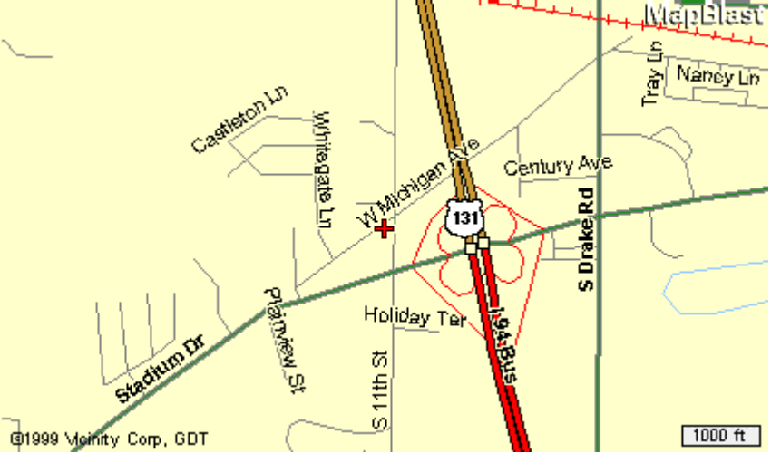

Red Roof Inn (Kalamazoo West)
5425 W. Michigan Av.
Kalamazoo, MI 49009
(616) 375-7400
(800) 843-7663 (Reservation Line)
Otis Golf Outing Block #B025000632

Gallagher’s (Formerly Chianti’s)
Gallagher’s is on Stadium Drive, about 1 mile east of the hotel.
4210 Stadium Drive
Kalamazoo, MI 49008
(616) 372-7177
Directions to Thornapple Creek from Red Roof Inn

Follow Michigan Ave east to Drake Rd.
Turn Left on Drake and drive a few miles north to Ravine Rd.
Turn left on Ravine Rd. And follow it to “F” Ave.
Turn left on “F” Ave and follow to Thornapple, on the left side of the road.

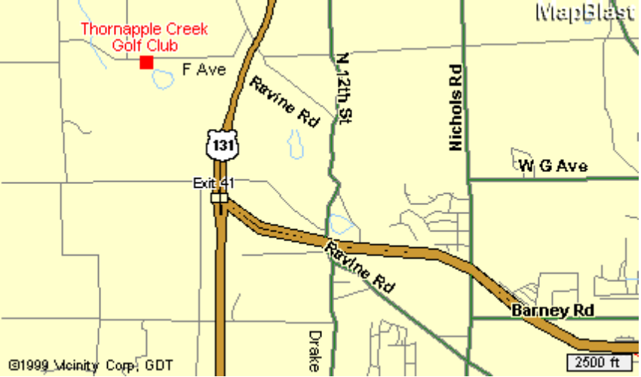

Thornapple Creek Golf Club
6415 W. F Ave
Kalamazoo, MI 49009
- 344-0040

(Alternate route to Thornapple from Red Roof Inn)
Get back on to US 131 North and follow it to the exit for “D” Ave.
Turn left onto D Ave, and drive 1 mile to Ravine Rd.
Turn left on Ravine Rd, and begin driving back south.
Follow the left fork to stay on Ravine Rd, and follow it to “F” Ave.
Turn right on “F” Ave. And follow it to Thornapple which will be on the left.
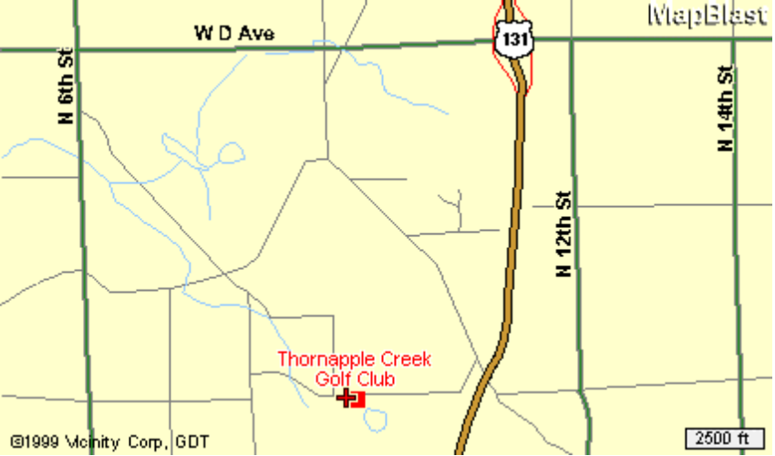

Directions to Heritage Glen from Red Roof Inn

Follow Stadium Drive west out of town.
Stadium will become “Red Arrow Highway”.
Follow Red Arrow Hwy west to 30th Street.
(Be patient, it is a few miles)
Turn right on 30th St. And follow to Heritage, about 1 or 2 miles down on right.

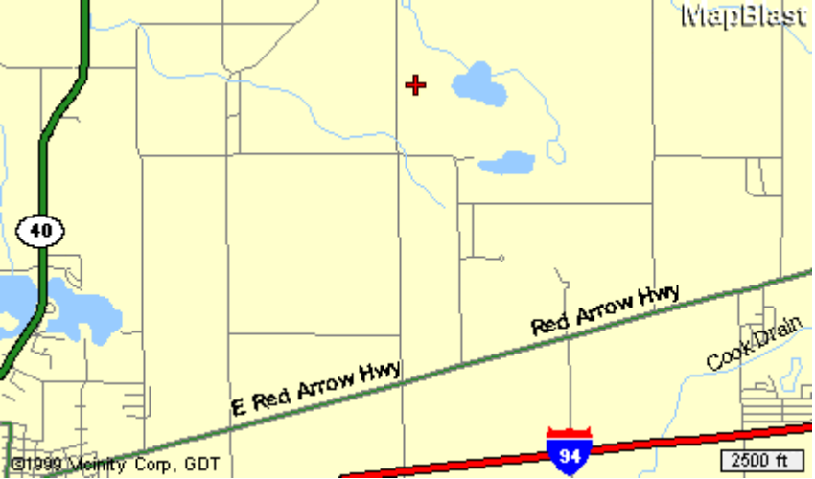

Heritage Glen Golf Club
29795 Heritage Lane
Paw Paw, MI 49079
(616) 657-2552


Thornapple Creek Golf Club
6415 West “F” Ave.
Kalamazoo, MI 49009
(616) 344-0040

Rated one of the most challenging courses by the Golf Association of Michigan. Enjoy a rare
combination of undisturbed natural beauty and finely manicured bent grass, a treat for any
golfer. The Creek’s 13th hole, a 618 yard par 5, was ranked as the best par 5 in the state, and
was also named to the Detroit Free Press’ “Dream 18”.

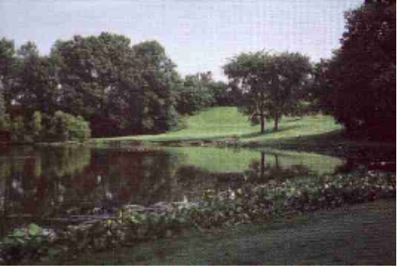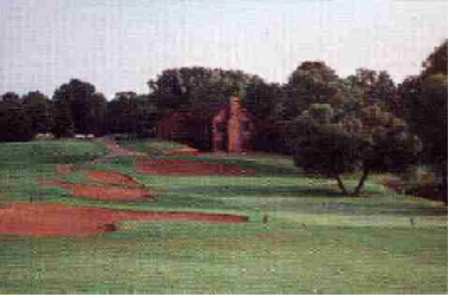

After your round enjoy the rustic log cabin clubhouse. Complete food and beverage service and
large seating capacity make it the ideal setting for heckling your fellow Otis participants as they
putt out on the 18th hole.

Blue Tees: Course Rating 72.3, Slope 133, 6595 yards
White Tees: Course Rating 70.0, Slope 127, 6122 yards


Heritage Glen Golf Club
29795 Heritage Lane
Paw Paw, MI 49079
(616) 657-2552

A challenging, public 18-hole, par 72 layout built on 235 acres of beautiful, rolling land in southwestern Michigan’s wine region. Opened in 1994, it is located five miles northeast of Paw Paw.

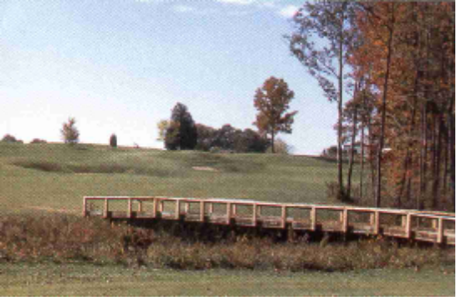
(The Adam Kommers Memorial Bridge)

On this beautifully maintained course, golfers enjoy three different settings on the front nine alone - pines, hardwoods, and a bit of the links effect. The bent grass greens, fairways, and tees are superbly manicured. Golfers need to make their mark on the front, because they wont be able to let up at all on the back nine!

The 6th hole is 625 yards from the back tees. It’s a narrow, double dogleg test that requires your best shot making ability.

Blue Tees: Course Rating 72.1, Slope 137, 6630 yards
White Tees: Course Rating 69.2, Slope 131, 6049 yards

